Supplementary Information:
Understanding the Effects of Multiphase Flow Properties in Transport-Limited Organic Electrosynthesis

Casey K. Bloomquist,¹ Ziqi Zhang,¹ Eray S. Aydil,¹ and Miguel A. Modestino¹

¹New York University, Tandon School of Engineering, Department of Chemical and Biomolecular Engineering, 6 Metrotech Center, Brooklyn, NY 11201, USA
Corresponding author: Miguel A. Modestino
E-mail: modestino@nyu.edu

Table of Contents
Chemicals and Materials 2
Electrochemical Reactor Setup and Operation 2
Chemical Quantification 3
Weber Number Calculations 5
Faradaic Efficiency, Production Rate, and Energy Productivity Calculations 5
Building Surrogate Models 6
Experimental Data 14

Chemicals and Materials
Acrylonitrile (AN, 99%), propionitrile (PN, 99%), and heptane (99%) were obtained from Sigma-Aldrich. Adiponitrile (ADN, 99%) was obtained from Acros Organics, 1,3,6 tricyanohexane (TCH, 99.81%) was obtained from AmBeed, sodium phosphate, tribasic (Na₃PO₄, 97%) was obtained from Spectrum Chemical Mfg Corp, ethylenediaminetetraacetic acid disodium salt dihydrate (EDTA, 0.5 M) was obtained from Fisher Chemical, tetrabutylammonium hydroxide (TBA, 40% wt. % in H2O) was obtained from TCI Chemicals, and toluene (99.9%) was obtained from VWR. The aqueous electrolyte solutions consisted of 0.5 M sodium phosphate, 0.03 M EDTA, and 0.02 M TBA. Cadmium foil (0.125 mm thick, 99.95%) was obtained from Goodfellow. FEP (fluorinated ethylene propylene) films (0.25 – 1 mm thick) were obtained from Holscot Europe.

Electrochemical Reactor Setup and Operation
Electrochemical reactions were conducted in a commercial undivided flow reactor (Analytical Sales and Services, F1088100). The reactor consisted of aluminum end plates, chemically resistant PFA gaskets, silicone alignment gaskets, stainless steel electrodes and a flow path film. The flow path film was laser cut from FEP with varying thickness (0.25–1.0 mm) to create a serpentine flow path with active electrode area exposed to flow of 6.4 cm² and the working electrode was covered with cadmium foil to serve as the cathode. Spring-loaded electrical contacts were used to supply power to the electrodes, and a DC power source (Korad KA3005P) was used to apply constant current. Aqueous electrolyte and acrylonitrile were delivered independently via syringe pumps (New Era Pump Systems, NE-1000), then combined in a T-junction upstream of the reactor to form a two-phase flow. All tubing used was Teflon FEP (1/16” ID, 1/8” OD) obtained from McMaster-Carr, and a glass syringe (50 mL) was obtained from Fisher Scientific and used for the organic phase.
Flow paths with thicknesses of 0.25, 0.5, and 1.0 mm and total flow rates of 2, 6, and 10 mL min⁻¹ were used. For each combination of interelectrode gap and total flow rate, experiments were run at current densities from 70 to 300 mA cm⁻² and AN fractions from 0.05 to 0.3. Experimental conditions were selected using the Hammersley quasi-random sequence algorithm (author: Mansour Torabi) implemented in MATLAB R2024a. This low-discrepancy sampling method generated uniformly distributed points across a two-dimensional parameter space defined by current density (70–300 mA cm⁻²) and AN fraction (0.05–0.3).
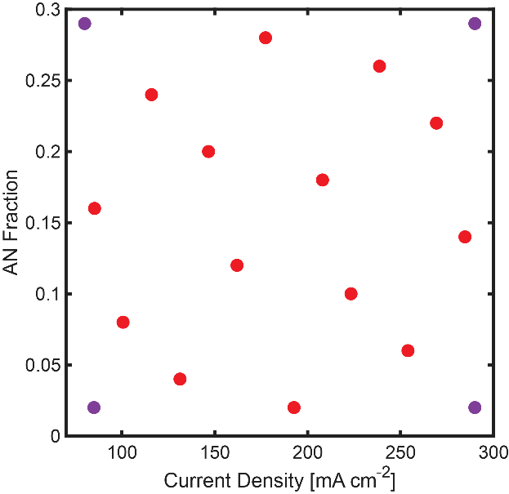
Fig. S1. Experimental design matrix showing selected conditions for current density and acrylonitrile (AN) fraction. Interior points (red) were selected using Hammersley quasi-random sampling to ensure uniform parameter space coverage. Boundary points (purple) were added at the parameter space extremes to improve Gaussian process regression (GPR) model fitting and extrapolation accuracy.

Chemical Quantification
Organic products were quantified using liquid-liquid extraction followed by gas chromatography-mass spectrometry (GC-MS) analysis. Pre-weighed glass vials were used to collect reaction samples during electrochemical experiments, and each vial was reweighed after sample collection to determine the precise mass of collected sample solution. Toluene containing an internal standard of n-heptane (0.04 M) was added at 25% by weight of the collected sample, and the two-phase mixture was stirred using a magnetic stir bar for 5 minutes at ambient temperature to extract the organic products into the toluene phase. After stirring, phases were allowed to separate under gravity for 5 minutes, and the organic (toluene) phase was extracted and filtered through a 0.45 μm PTFE syringe filter to remove any particulates before GC-MS analysis.
GC-MS analysis was performed on a Shimadzu QP2010/GCMS-QP2020 NX gas chromatograph-mass spectrometer equipped with an Rxi-5Sil MS GC capillary column (30 m length, 0.25 mm ID). The GC temperature program was as follows: hold at 40 °C for 1 min, ramp at 20 °C/min to 300 °C and hold at 300 °C for 10 min. Quantification was performed using a two-step calibration procedure to account for the varying acrylonitrile (AN) concentrations in the samples using the calibration curves shown in Fig. S2. First, the AN concentration in each sample was determined using a dedicated AN calibration curve referenced to the heptane internal standard. This AN concentration was then used to calculate the AN fraction in the sample. Subsequently, product concentrations (ADN, TCH, and PN) were determined using compound-specific calibration curves generated at discrete AN fractions (0.0, 0.1, 0.2, and 0.3). For samples with intermediate AN fractions, concentrations were calculated by linear interpolation between the appropriate calibration curves.
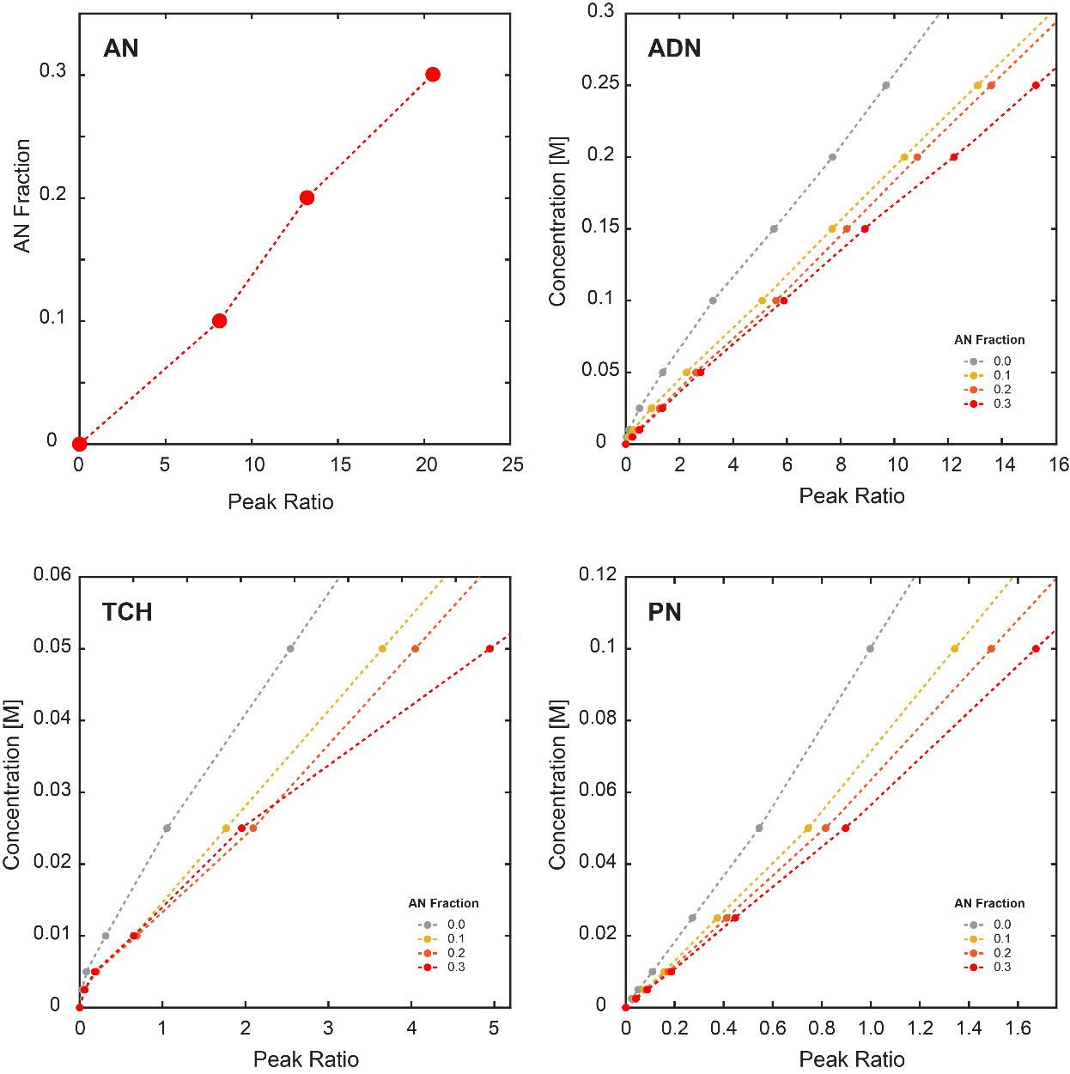
Fig. S2. GC-MS calibration curves for quantification of acrylonitrile (AN), adiponitrile (ADN), 1,3,6-tricyanohexane (TCH), and propionitrile (PN). Peak area ratios represent the ratio of analyte peak area to n-heptane internal standard peak area. Calibration curves were generated at four different AN fractions (0.0, 0.1, 0.2, and 0.3 M) to account for AN fraction effects during quantification. Each calibration point represents the mean of at least three independent measurements.

Weber Number Calculations
The Weber numbers for each phase were calculated using:
$$\begin{aligned}{We}_{i}=\frac{ρ_{i}v_{i}^{2}l}{σ}\#\left(S1\right)\end{aligned}$$

where ρ_{i} is the density of phase i (ρ_{organic} = 810 kg m⁻³, ρ_{aqueous} = 1000 kg m⁻³), v_{i} is the superficial velocity of phase i, l is the interelectrode gap, and σ is the interfacial tension between the two phases. The interfacial tension is estimated using the Girifalco-Good correlation,
$$\begin{aligned}{σ=γ}_{org,aq}=γ_{org}+γ_{aq}-2Φ\sqrt{γ_{org}γ_{aq}}\#\left(S2\right)\end{aligned}$$
where $γ_{org}$ and $γ_{aq}$ are the surface tension of the organic and aqueous phase, respectively ($γ_{org}=$ 27.54 mN m⁻¹, $γ_{aq}=$ 72 mN m⁻¹), and $Φ$ is an interaction parameter (simplified to $Φ=1$) such that $σ≅$ 10.5 mN m⁻¹.

Faradaic Efficiency, Production Rate, and Energy Productivity Calculations
Faradaic efficiency for each species produced is calculated by,
$$\begin{aligned}{FE}_{A}= \frac{C_{A, measured}}{C_{A,theoretical}}\#\left(S3\right)\end{aligned}$$
where $C_{A, measured}$ is the concentration of species A produced, measured using GC-MS, and $C_{A,theoretical}$ is the theoretical total concentration produced as determined by Faraday’s law,
$$\begin{aligned}C_{A,theoretical}= \frac{i}{nFQ} ,\#\left(S4\right)\end{aligned}$$
where $i$ is the applied current (A), $n$ is the number of electrons involved in the reaction (2 for ADN, TCH, and PN), F is Faraday’s constant (96,485 C/mol), and Q is volumetric flow rate (L/s).

The ADN production rate,${ PR}_{ADN}$ (kg cm⁻² h⁻¹) was calculated using,
$$\begin{aligned}{PR}_{ADN}= \frac{j_{ADN}}{nF}\left(\frac{3600 M_{ADN}}{A_{electrode}}\right)\#\left(S5\right)\end{aligned}$$
where $j_{ADN}$ is the partial current density towards ADN (A), $M_{ADN}$ is the molar mass of ADN (kg/mol) and $A_{electrode}$ is the electrode area (cm²).

The ADN energy productivity was calculated using,
$$\begin{aligned}{EP}_{ADN}= \frac{{PR}_{ADN}A_{electrode}}{P}\#\left(S5\right)\end{aligned}$$
where ${PR}_{ADN}$ is the ADN production rate (kg cm⁻² h⁻¹), $A_{electrode}$ is the electrode area (cm²), and P is the power (kW) calculated from the current applied (A) and the measured two-electrode potential (V).

Building Surrogate Models
Gaussian Process Regression (GPR) models were constructed using fitrgp in MATLAB's Statistics and Machine Learning Toolbox. The models were trained using the following input arguments: KernelFunction = "squaredexponential", FitMethod = "exact," PredictMethod = "exact," Standardize = 1. The noise standard deviation parameter, Sigma, was held constant (ConstantSigma = True) and tuned to balance model fidelity without overfitting. Sigma values were selected by evaluating measured vs. predicted plots (Fig. S3 and S4), inspecting 3D model surfaces for realistic smoothness, and assessing prediction standard deviations across the parameter space. Lower sigma values produced overfit models with unrealistic fine-scale variations, while higher sigma values resulted in underfit models that failed to capture experimental trends, illustrated in Fig. S5. The optimal sigma values (σ_{FE,ADN} = 5, σ_{FE,TCH} = 1, σ_{FE,PN} = 2, σ_{PR,ADN} = 2 x 10⁻⁵, σ_{EP,ADN} = 0.03) provided robust models that accurately reproduced experimental data while maintaining realistic prediction uncertainties. Model validation was conducted primarily through measured vs. predicted comparisons, supplemented by visual inspection of 3D response surfaces to ensure physically reasonable behavior. The trained models were used to generate continuous predictions across the parameter space by evaluating the GPR on a regular grid of points.

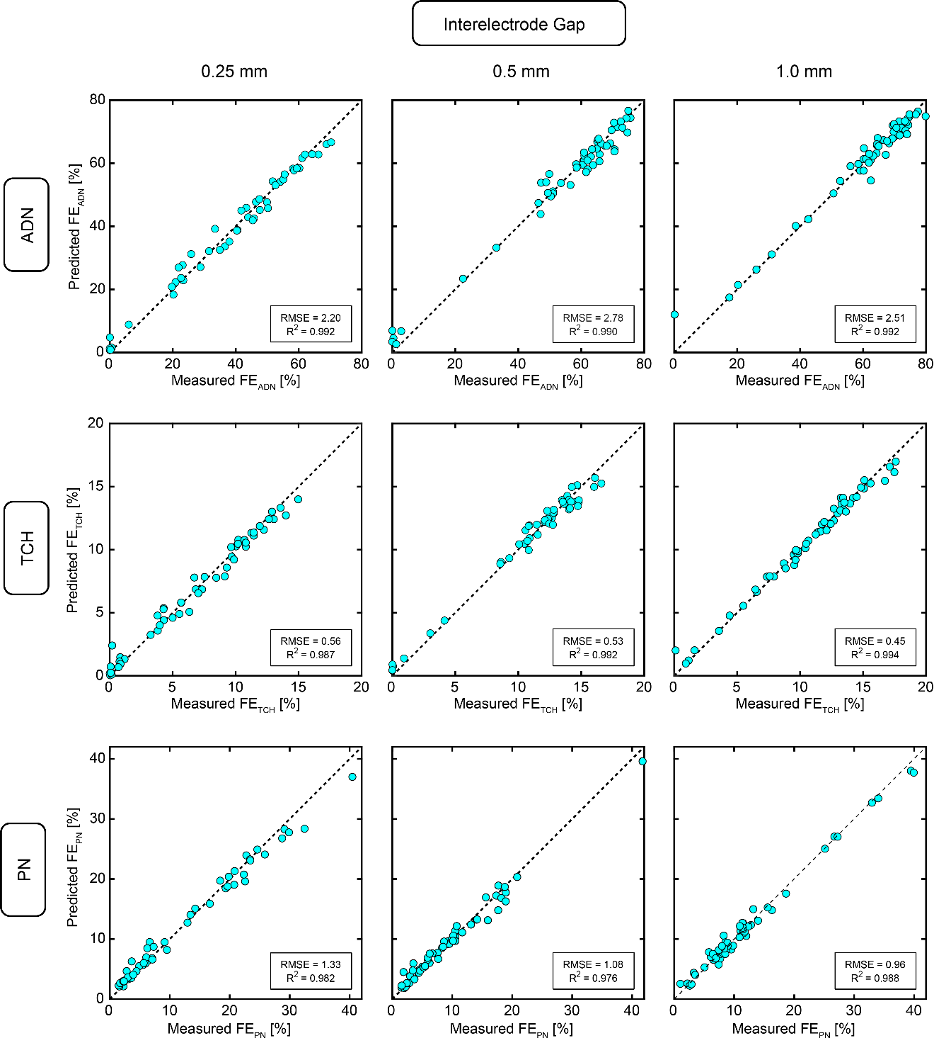
Fig. S3. Model validation for Faradaic efficiency predictions across interelectrode gaps. Measured vs. predicted plots for ADN, TCH, and PN Faradaic efficiencies for all interelectrode gaps (0.25, 0.5, and 1.0 mm). Dashed lines indicate perfect agreement (slope = 1). Root mean square errors (RMSE) and R² are shown in the individual plots. The strong correlation across all gaps and products demonstrates robust model performance for the primary reaction products.
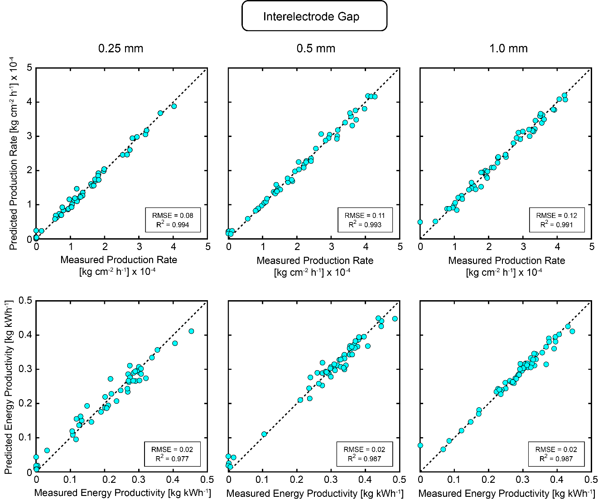
Fig. S4. Model validation for production metrics across interelectrode gaps. Measured vs. predicted plots for ADN, production rate and energy productivity for all interelectrode gaps (0.25, 0.5, and 1.0 mm). Dashed lines indicate perfect agreement (slope = 1). Root mean square errors (RMSE) and R² are shown in the individual plots. The strong correlation across all gaps and products demonstrates robust model performance for the primary reaction products.

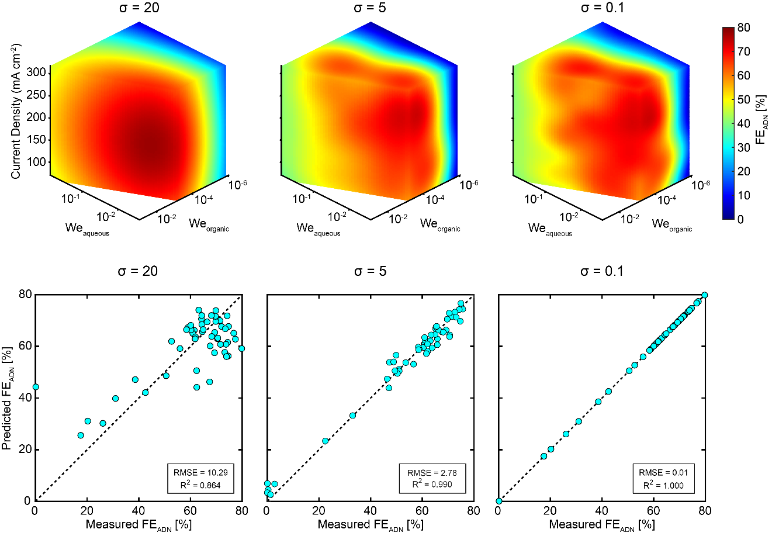
Fig. S5. Gaussian Process Regression model tuning demonstrating the effect of noise standard deviation parameter (σ) selection. Top row shows 3D response surfaces for FE_{ADN} for underfitting (σ = 20), optimal fit (σ = 5), and overfitting (σ = 0.1). Bottom row shows corresponding measured vs. predicted plots with RMSE and R² values. Underfitting produces overly smooth surfaces that oversimplify experimental trends, while overfitting creates unrealistic fine-scale features. The optimized sigma value balances model fidelity with appropriate uncertainty quantification.

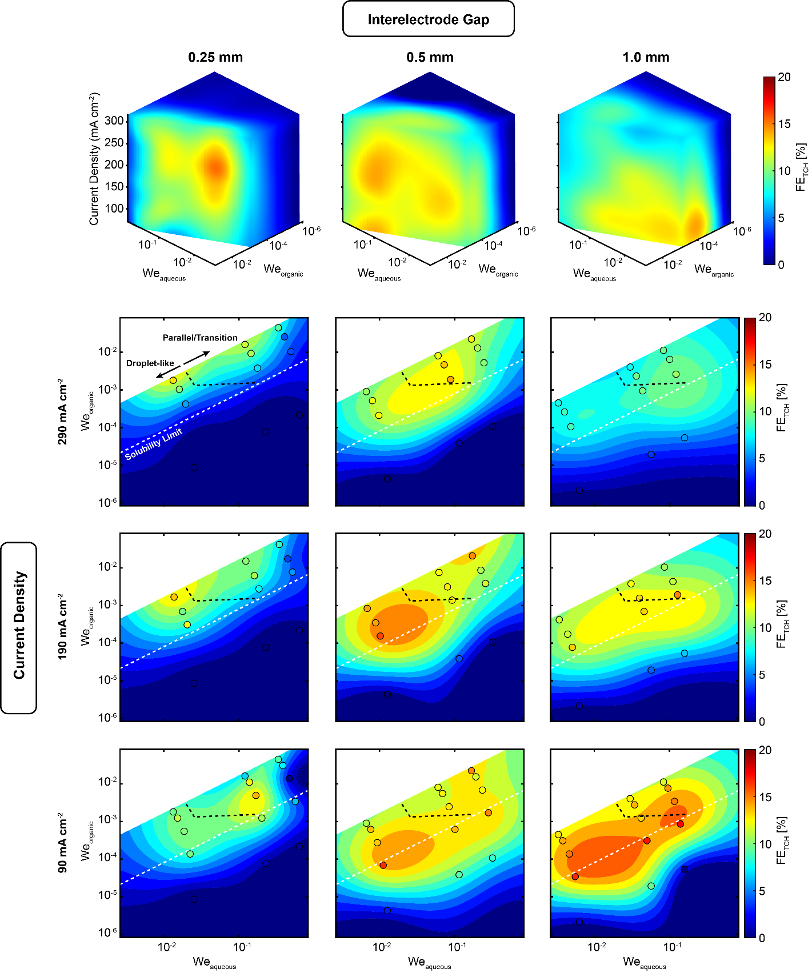
Fig. S6. TCH Faradaic efficiency (FE_{TCH}) as a function of aqueous Weber number, organic Weber number, and current density for different interelectrode gaps. The top row displays 3D visualizations for each interelectrode gap (0.25, 0.5, and 1.0 mm), while the bottom panels show 2D slices at three current densities (90, 190, and 290 mA cm⁻²). The black dashed line indicates the transition from droplet-like to parallel-like flow regimes and the white dashed line indicates the AN solubility limit.
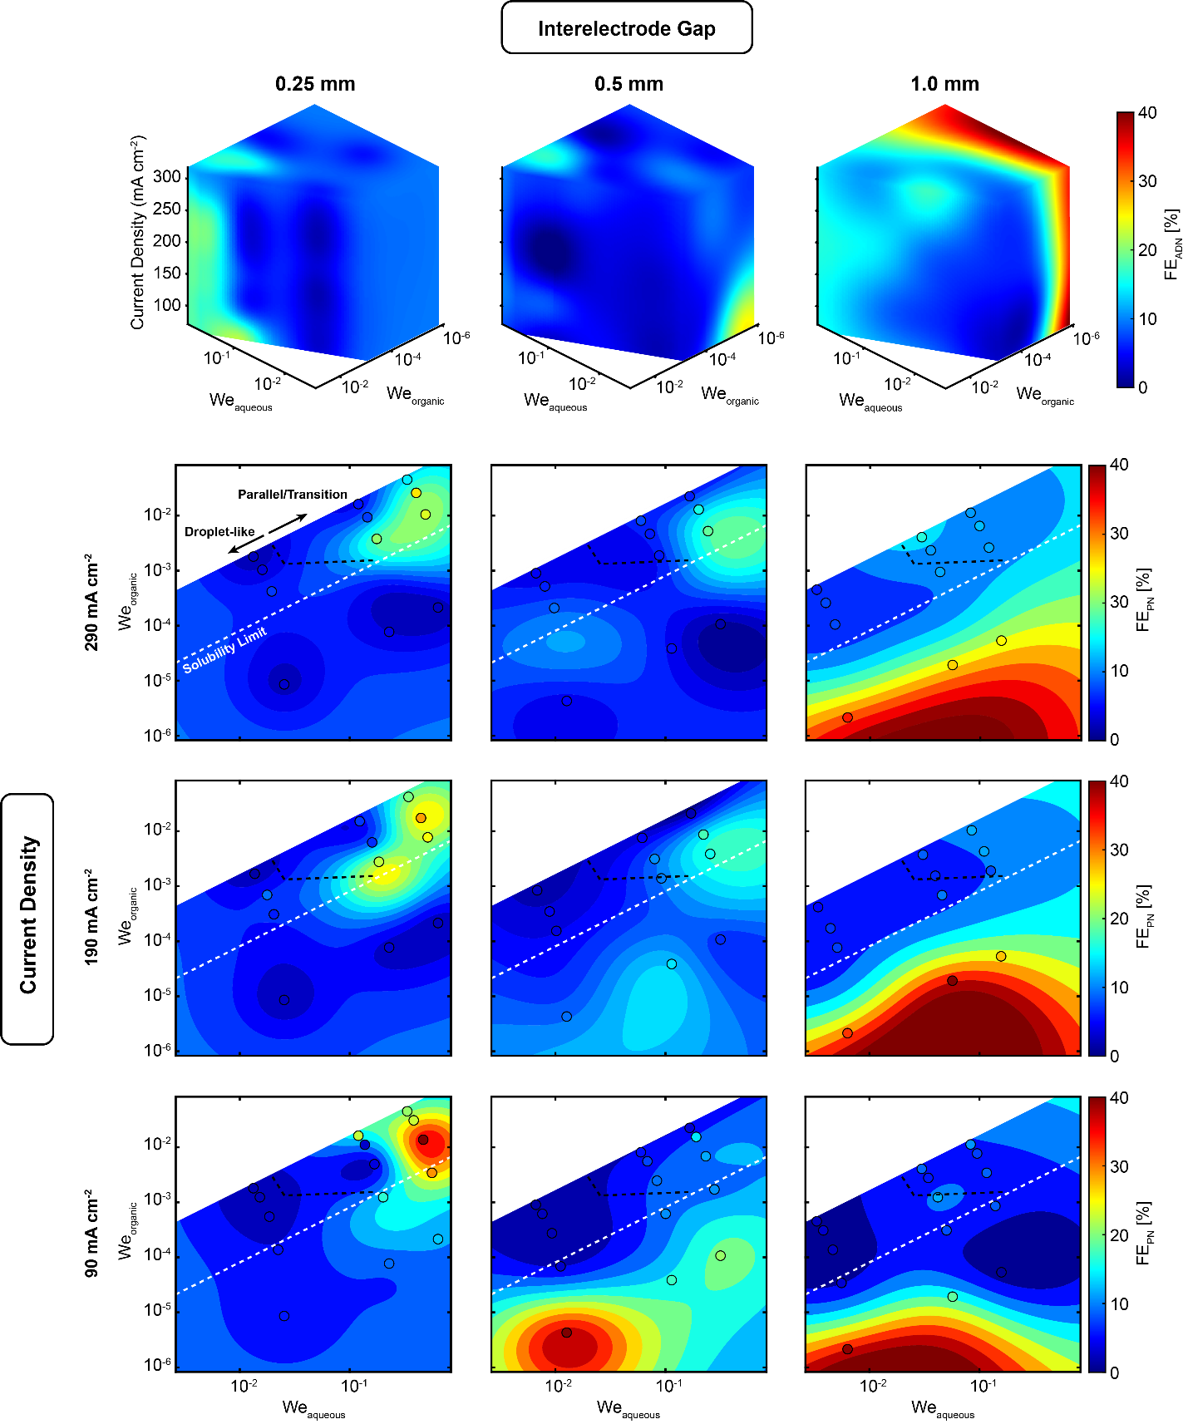
Fig. S7. PN Faradaic efficiency (FE_{PN}) as a function of aqueous Weber number, organic Weber number, and current density for different interelectrode gaps. The top row displays 3D visualizations for each interelectrode gap (0.25, 0.5, and 1.0 mm), while the bottom panels show 2D slices at three current densities (90, 190, and 290 mA cm⁻²). The black dashed line indicates the transition from droplet-like to parallel-like flow regimes and the white dashed line indicates the AN solubility limit.
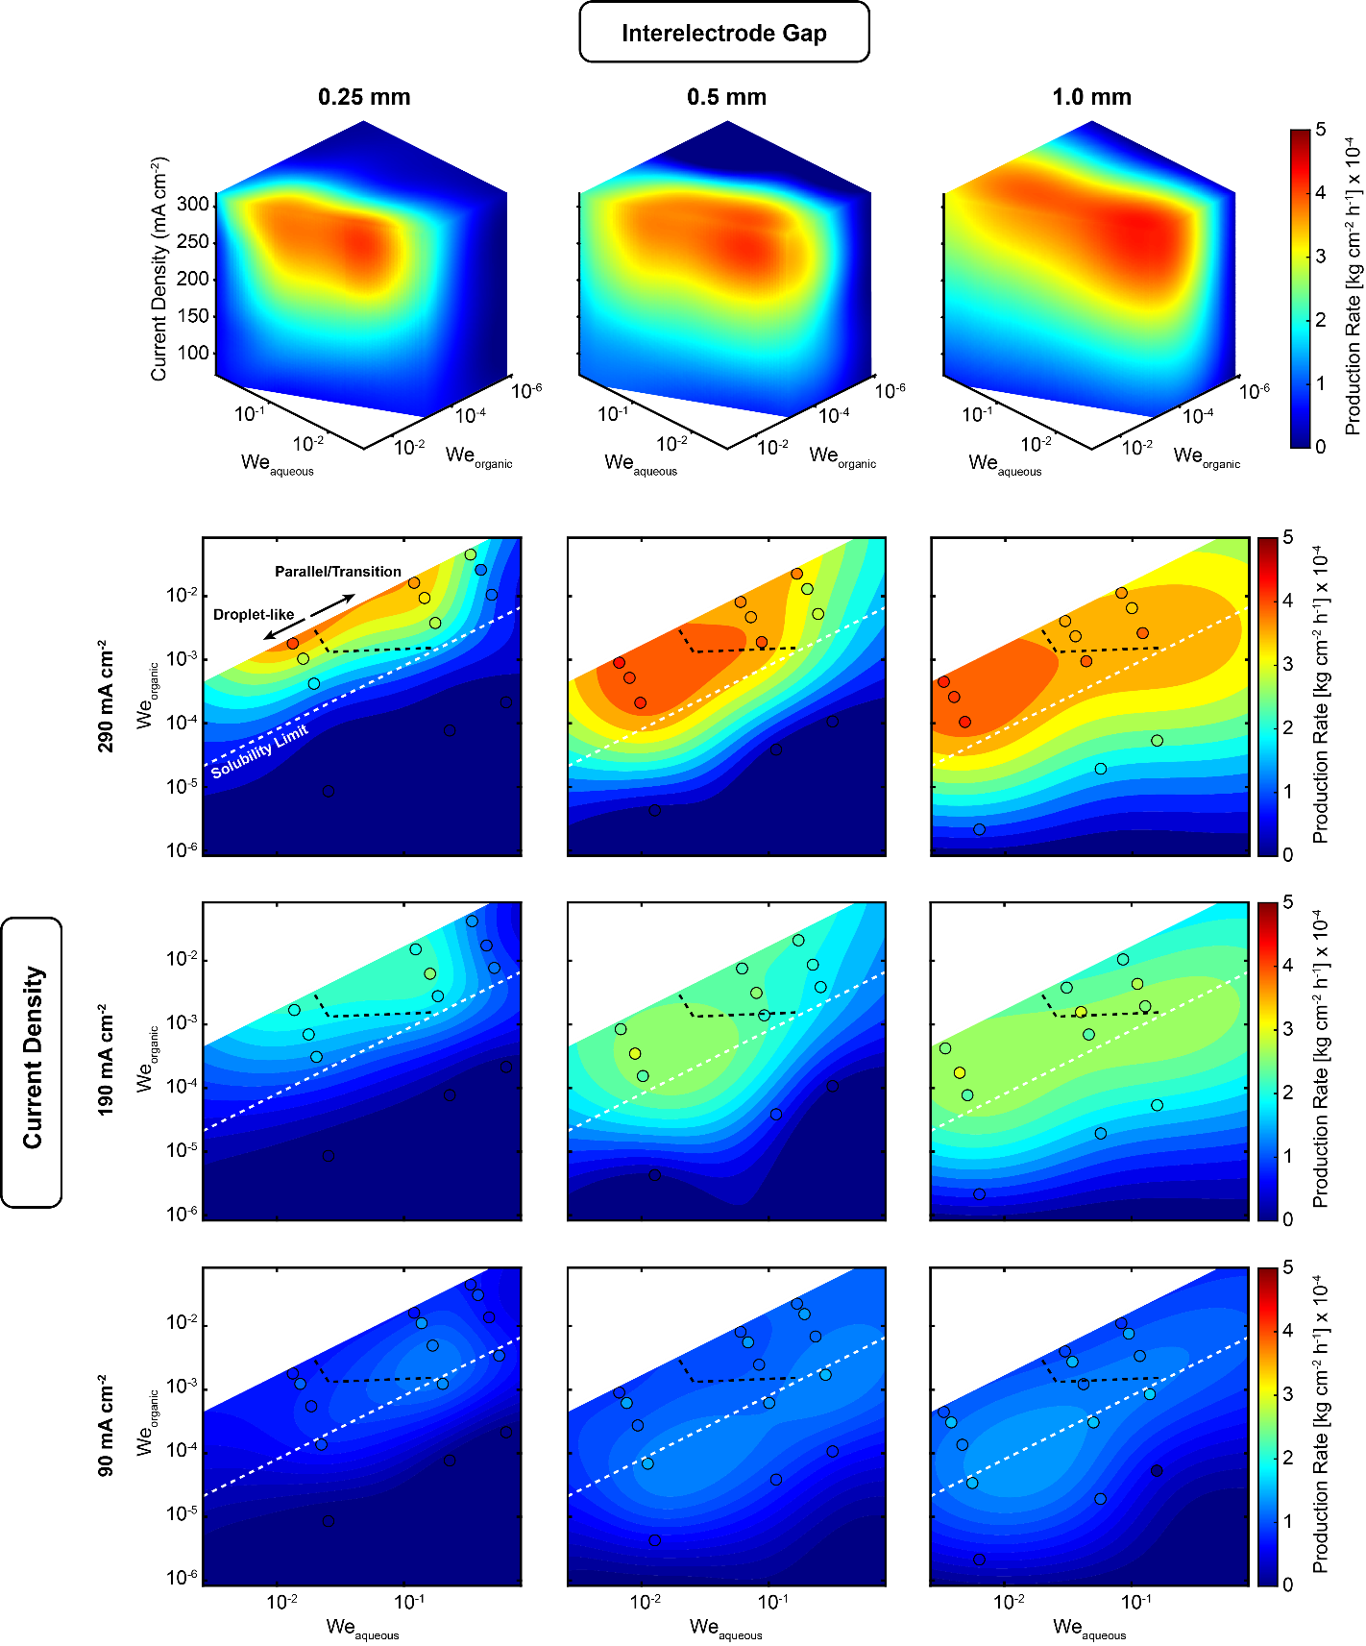
Fig. S8. ADN Production Rate as a function of aqueous Weber number, organic Weber number, and current density for different interelectrode gaps. The top row displays 3D visualizations for each interelectrode gap (0.25, 0.5, and 1.0 mm), while the bottom panels show 2D slices at three current densities (90, 190, and 290 mA cm⁻²). The black dashed line indicates the transition from droplet-like to parallel-like flow regimes and the white dashed line indicates the AN solubility limit.
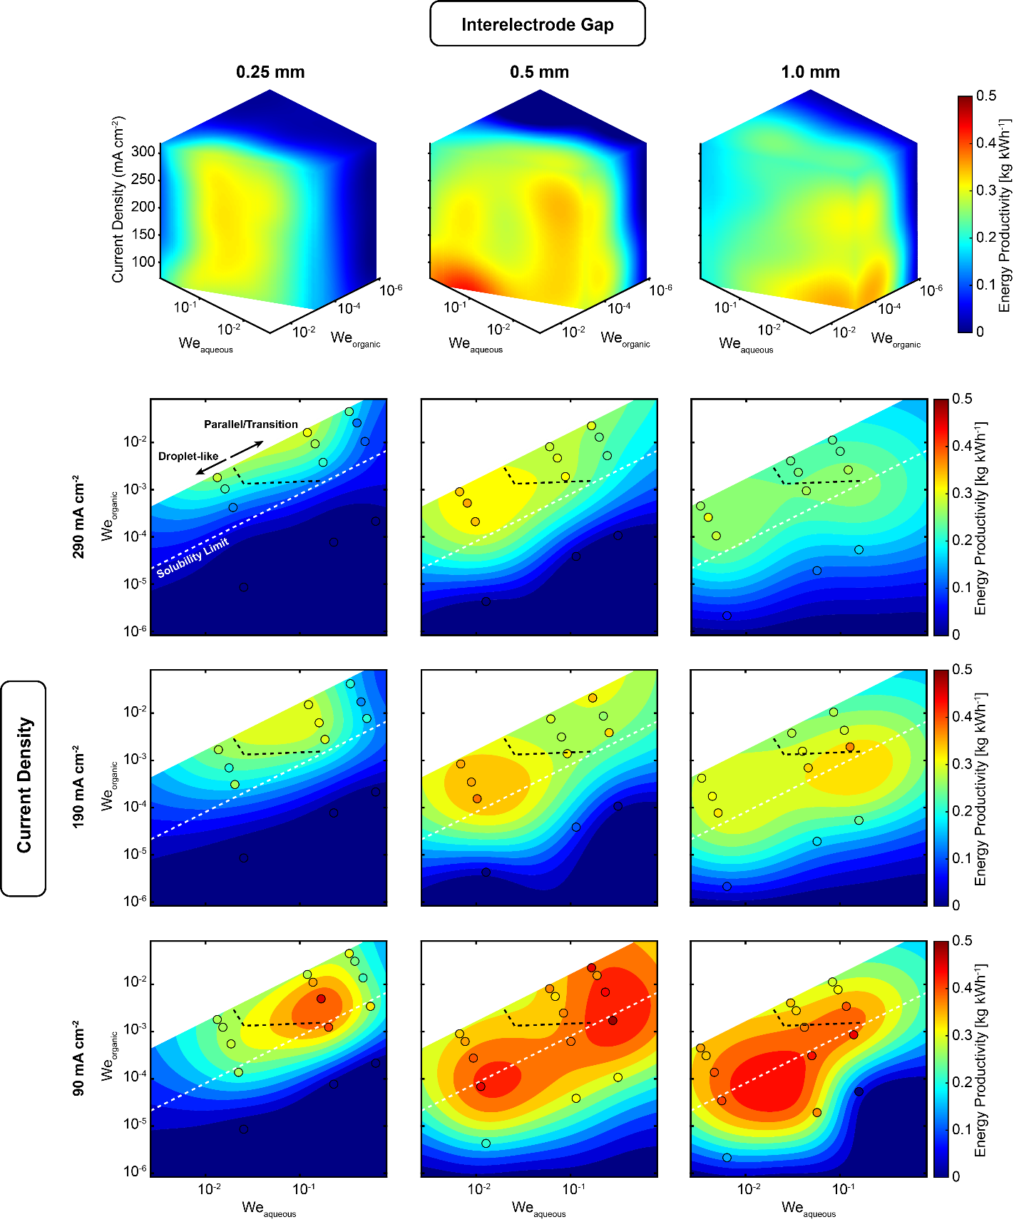
Fig. S9. ADN Energy Productivity as a function of aqueous Weber number, organic Weber number, and current density for different interelectrode gaps. The top row displays 3D visualizations for each interelectrode gap (0.25, 0.5, and 1.0 mm), while the bottom panels show 2D slices at three current densities (90, 190, and 290 mA cm⁻². The black dashed line indicates the transition from droplet-like to parallel-like flow regimes and the white dashed line indicates the AN solubility limit.

Experimental Data
Table S1 Parameter descriptions
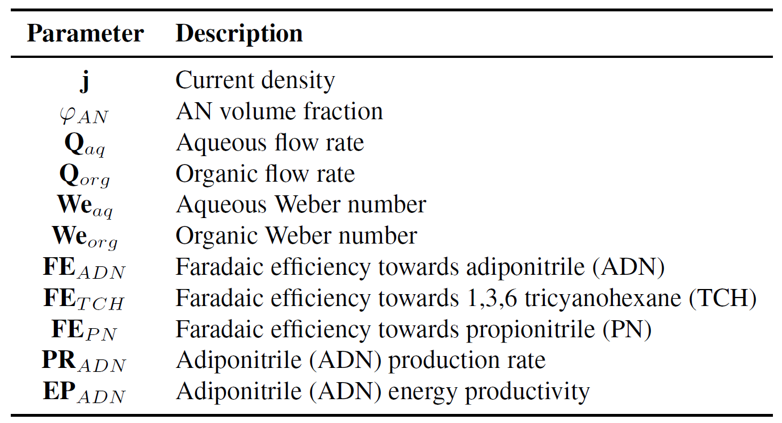

Table S2 Interelectrode Gap: 0.25 mm, Total Flow Rate: 2 ml min⁻¹
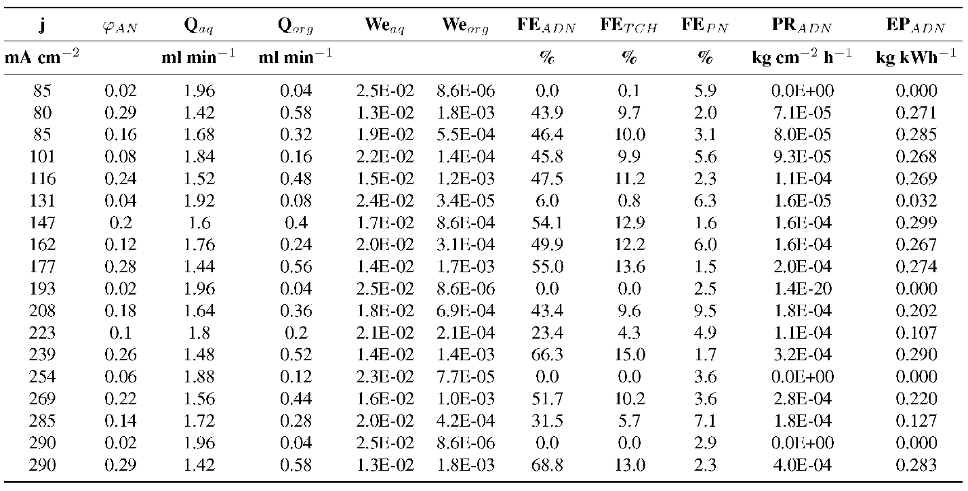

Table S3 Interelectrode Gap: 0.25 mm, Total Flow Rate: 6 ml min⁻¹
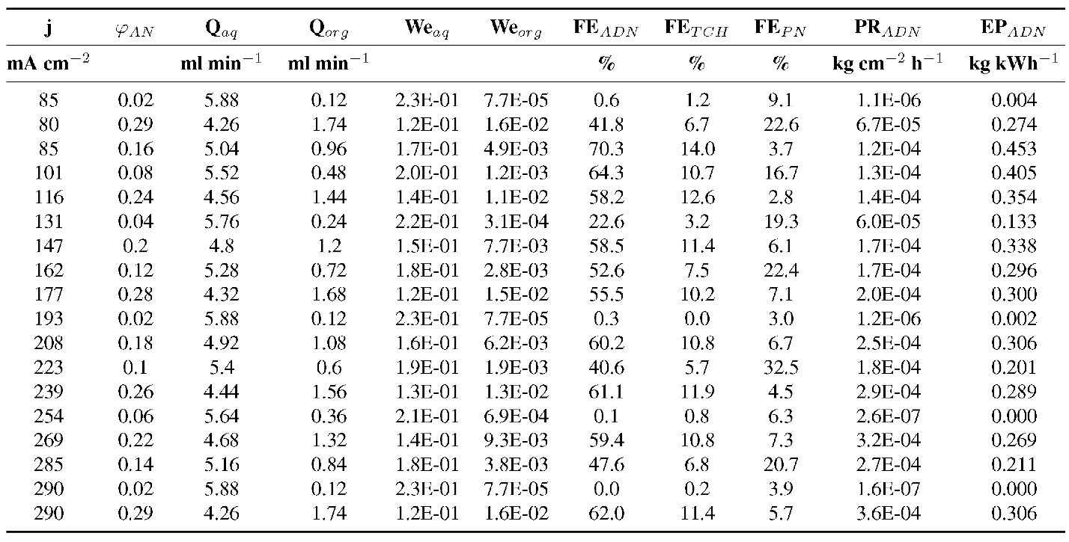

Table S4 Interelectrode Gap: 0.25 mm, Total Flow Rate: 10 ml min⁻¹
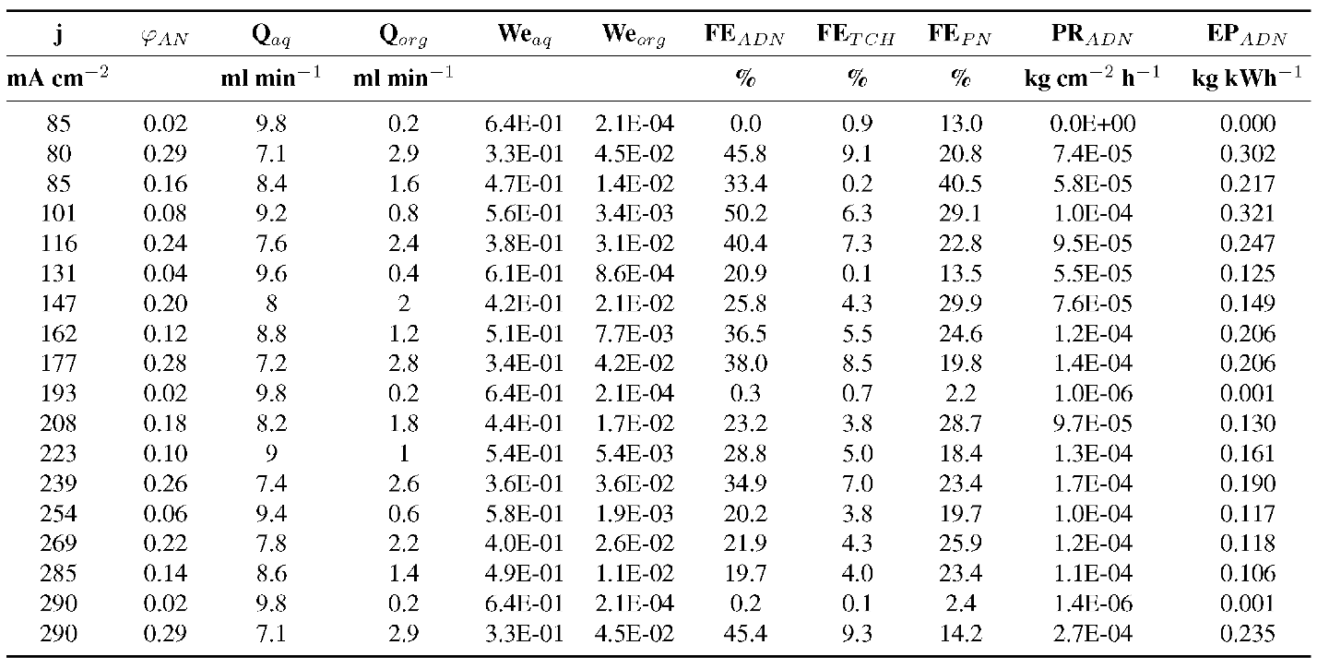

Table S5 Interelectrode Gap: 0.5 mm, Total Flow Rate: 2 ml min⁻¹
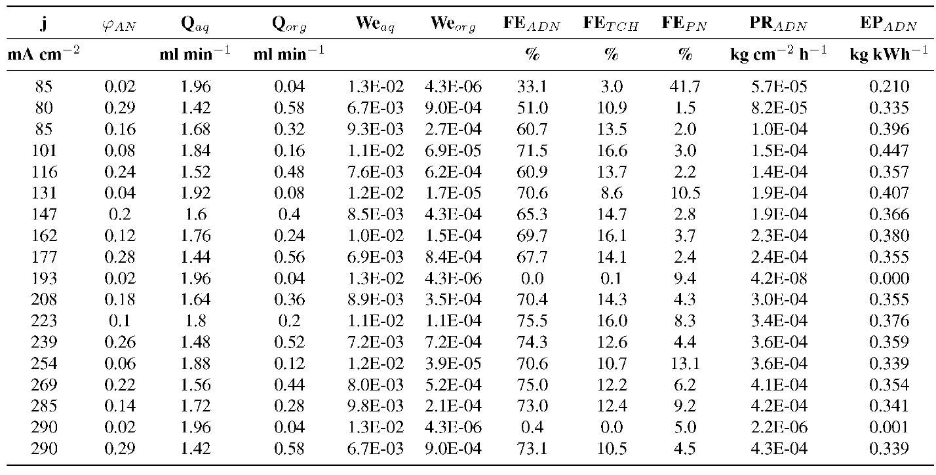

Table S6 Interelectrode Gap: 0.5 mm, Total Flow Rate: 6 ml min⁻¹
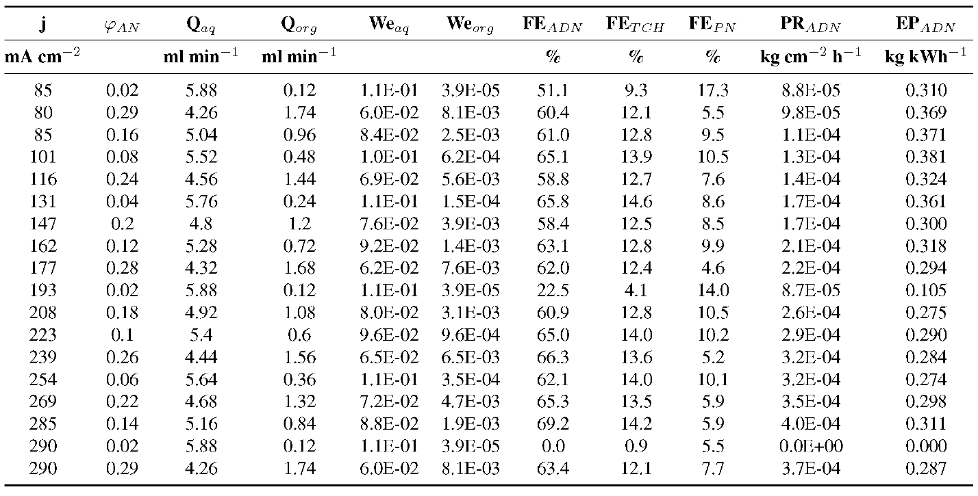

Table S7 Interelectrode Gap: 0.5 mm, Total Flow Rate: 10 ml min⁻¹
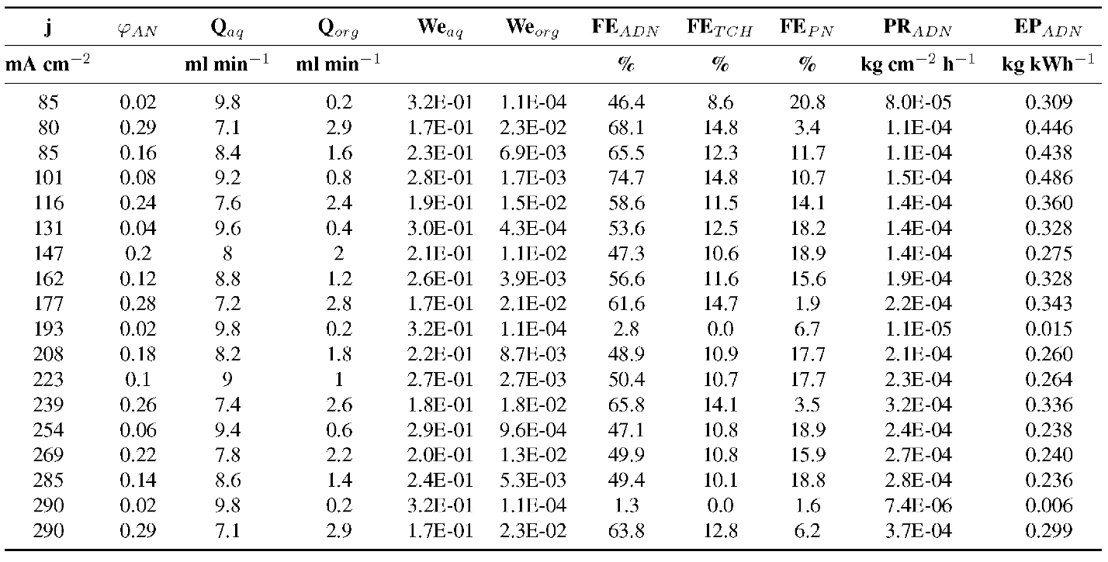

Table S8 Interelectrode Gap: 1.0 mm, Total Flow Rate: 2 ml min⁻¹
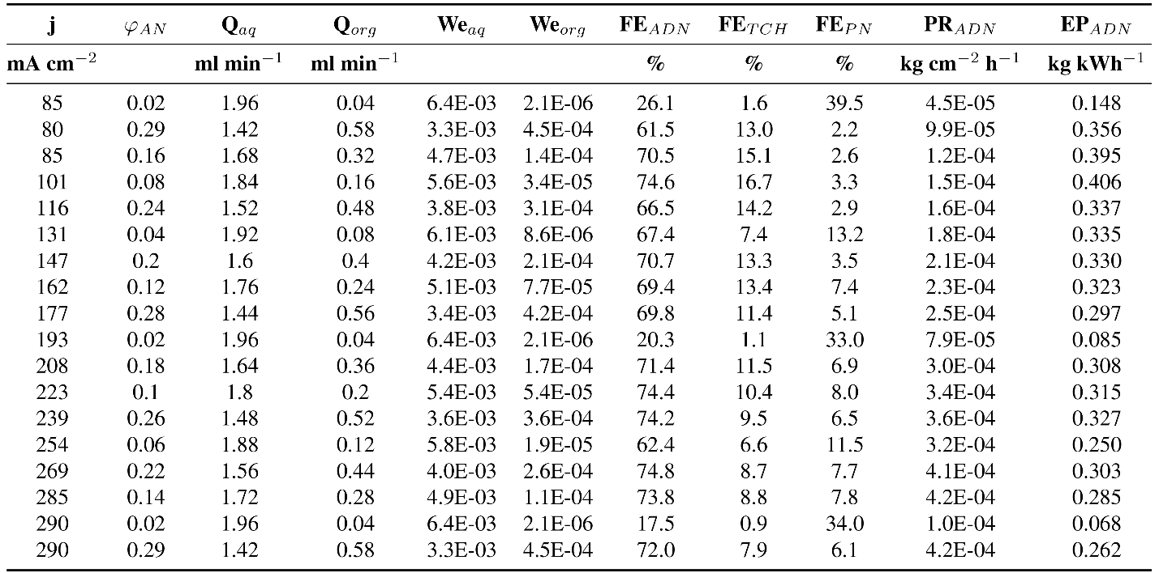

Table S9 Interelectrode Gap: 1.0 mm, Total Flow Rate: 6 ml min⁻¹
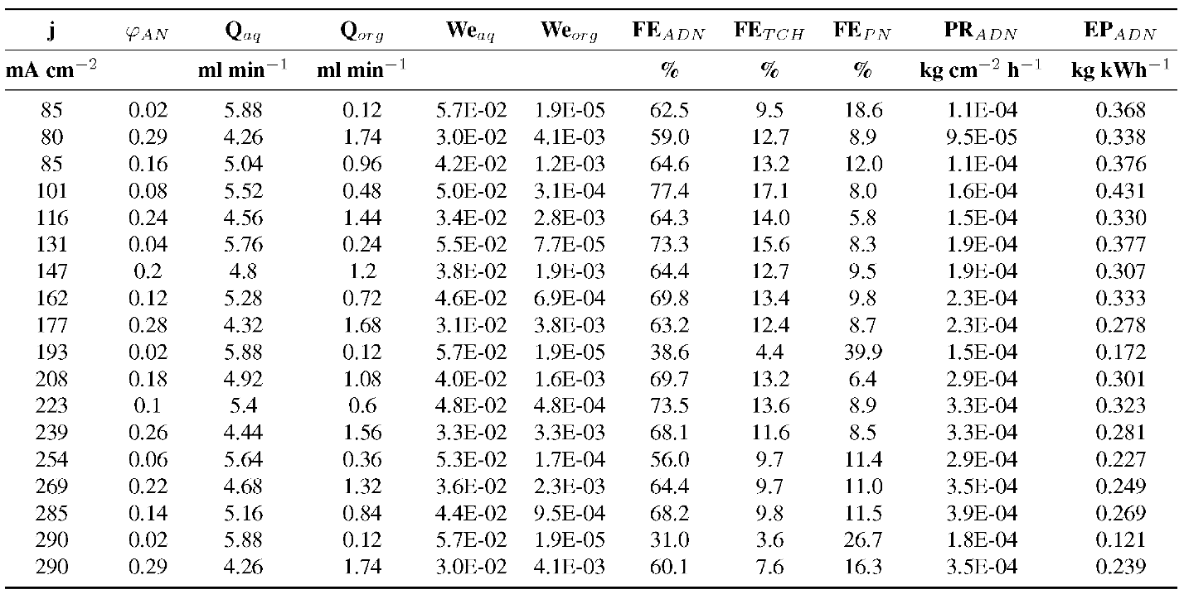

Table S10 Interelectrode Gap: 1.0 mm, Total Flow Rate: 10 ml min⁻¹
